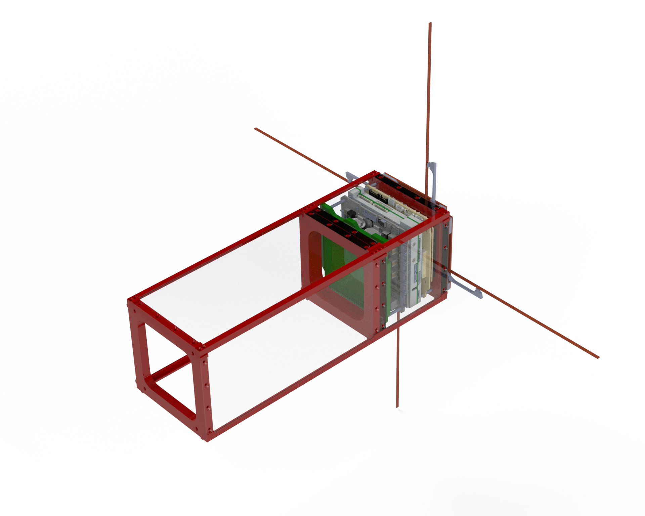

**UPS-X bus @ Virginia Tech**

The UtProSat-X is a Virginia Tech bus for SmallSats. Its current version comprises a modular structure and an onboard computer. This bus leverages flight heritage from multiple VT CubeSat missions throughout the last five years, and it is an ongoing development. Future versions of this bus will incorporate a VT-GPS module, a VT-UHF deployable antenna, and other components.

The Virginia Tech’s Payload Control Module (VT-PCM) is a space-graded onboard computer (OBC) printed circuit board (PCB) designed and manufactured at Virginia Tech. Leveraging the STM32F4 microprocessor, an Arm Cortex-M4, it is designed to operate multiple payload experiments for a single mission architecture. VT-PCM is also ready for inter-board connector standard: PC/104, facilitating the combination with a broad number of commercial off-the-shelf components of different vendors.

|  | The VT-PCM features:   * Power Lines: 3.3V, 5V, and 8.4V * 1x UART (PC104) * 1x UART for an extra payload PCB * 1x CAN (PC104) * 3x embedded IMU Units (BMI270) * 1x SDIO 32GB SD Card * 1x 8.4V Stepper Motor Driver * Other Peripheral Connectors: 2x Servo Motors, 1x Enconder, 2x Cameras * Embedded Software Architecture: RTOS, AX25 * Spacecraft Software Implementations: Power and Data Management; Radio-Key Authentication |
| --- | --- |

Contacts: Dr. Jonathan Black, [jonathan.black@vt.edu](mailto:jonathan.black@vt.edu) | Gustavo Gargioni, [gargioni@vt.edu](mailto:gargioni@vt.edu)